John Michael Go
Career Entry Level Java Programming
Date: Jan. 14, 2013

DAY 2

Program Name: Digits3

Objective: Hello World Program and sum of two numbers

Algorithm:

- User inputs any 3 digit number.
- Program will add the total of the 3 digit number.

Flowchart:

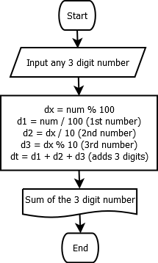

Pseudocode:

Screenshot:

Pseudocode:

import java.util.*;
import java.io.*;

public class Digits3{

static Scanner console = new Scanner (System.in);

public static void main(String[]args){
// variable declaration
int num, dx, d3, d1, d2, dt;
System.out.println("");
System.out.print("Enter a three digit Number: ");
num = console.nextInt();
// program will only accept numbers within 100 to 999
if (num>99 && num<1000){

dx = num % 100;
d1 = num / 100; // gets the 1st digit
d2 = dx / 10; // gets the 2nd digit
d3 = dx % 10; // gets the 3rd digit
dt = d1+d2+d3; // adds the three numbers

//output the total of the three digit number
System.out.println("");
System.out.println("The sum of the three numbers is: " + dt);
System.out.println("");

}else{
//program will ask user to try entering a three digit number
System.out.println("");
System.out.println("Please enter a THREE digit number.");
System.out.println("");

}

}

}

Screenshot:

